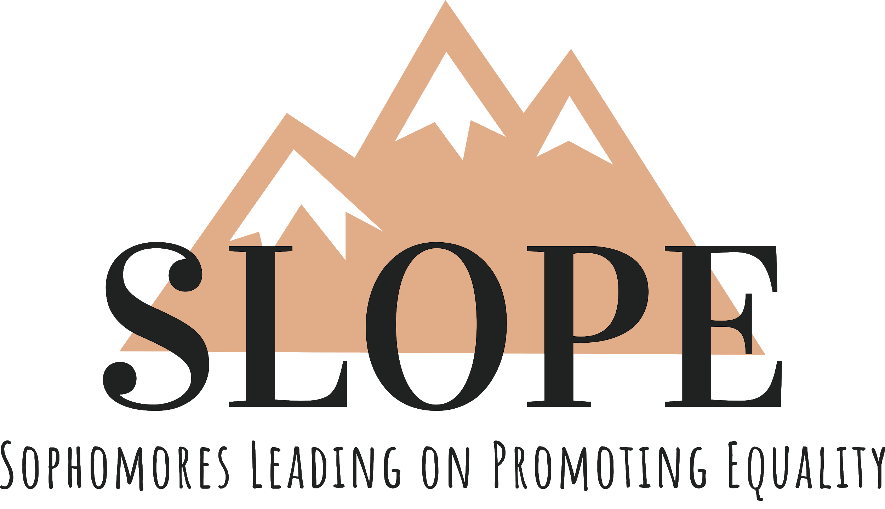

Howdy Ags! Sophomores Leading On Promoting Equality is a new SLO founded in 2019. We are looking for current sophomores (Class of 2022) to be members who are committed, spirited, and willing to help others.

Mission Statement: SLOPE intends to promote equality in the Texas A&M community and the surrounding community through leadership and community service outreach. We envision creating an environment in which all Aggies are equal and shaping the leaders of tomorrow.

Our general meetings fall on every Tuesday at 7:00 PM. If you plan to commit to this organization, please ensure this time period of your schedule is open. We want you to be able to form a dynamic relationship with other members, the staff, and the speakers who share their experiences with you. This is only possible if you put in the time and effort to be there.

Name: _______________________________________________________________________
Last First Middle Initial
E-mail:____________________________________ Phone #: __________________________
Gender Identity: ____________________________ Is your GPR above a 2.0? Yes No T-shirt size: S M L XL XXL

List other commitments and the amount of time committed per week:

Please type your answers to the following questions on a separate word document not to exceed two pages single spaced. Submit the first page of this document, a picture of yourself for referencing purposes, and the document containing your responses to slopeexecs@gmail.com by 5pm on Thursday, September 19th.

An email regarding Interviews will be sent shortly after the application deadline.

- What do you hope to gain through joining SLOPE? If chosen what can you contribute?
- Why do you think promoting equality is important?
- Who is your favorite leader? What leadership qualities do you admire about them?
- What song describes you? Why?

Thanks, and Gig’Em!
SLOPE Staff

If you have any questions, please contact our Email with the Subject Title being “SLOPE App Questions: Your Name”
~ slopeexecs@gmail.com ~

