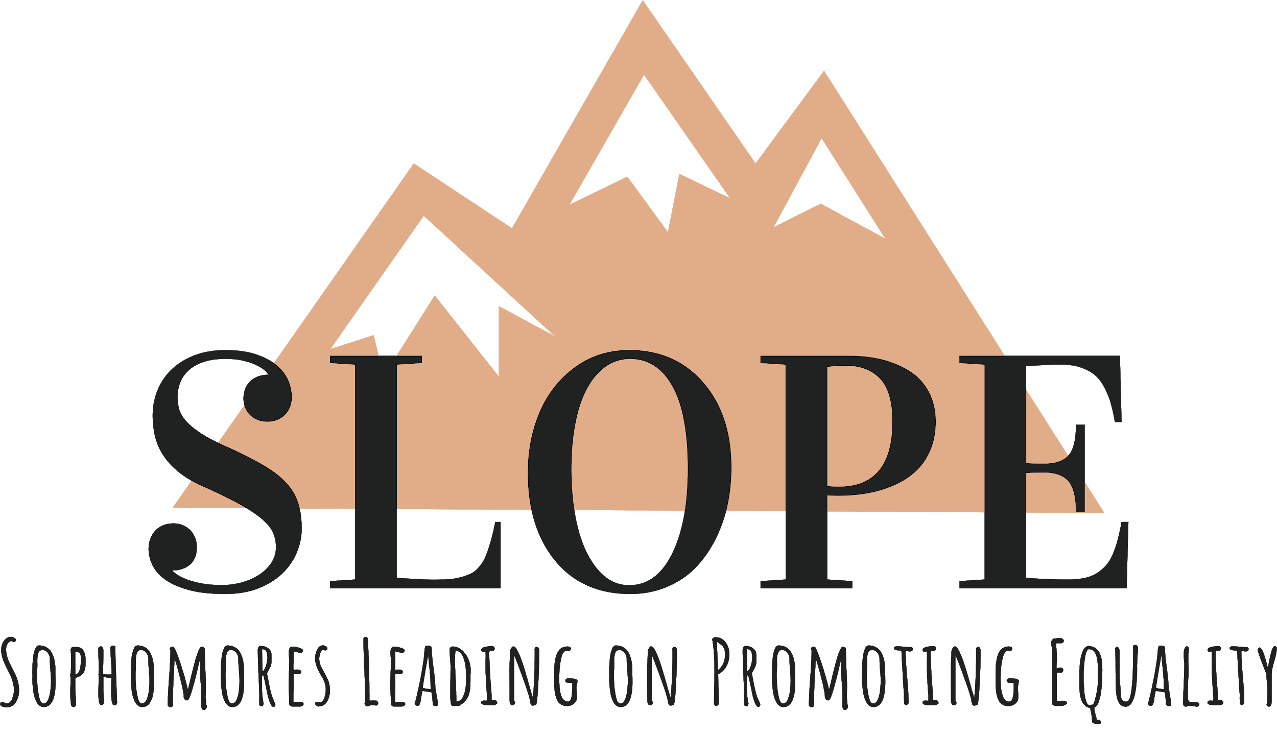
SLOPE 2020-2021 Counselor Application
Thank you for your interest in applying for a counselor position for the 2020-2021 academic year! Please read our mission statement and counselor responsibilities, expectations, and attendance requirements before submitting your application.

Mission Statement:
SLOPE intends to promote equality in the Texas A&M community and the surrounding community through leadership and community service outreach. We envision creating an environment in which all Aggies are equal and shaping the leaders of tomorrow.

Counselor Responsibilities and Expectations:
- Co-chairing one of five committees with two other counselors (allowing for the most direct involvement with the sophomores)
- Planning events that will help promote the purpose of our organization through each committee
- Working with other counselors to coordinate activities and serving in any capacity as needed
- Leading committee meetings weekly and ensuring that all sophomores are attending
- Participating in and attending planned SLOPE events
- Enforce and follow the policy stated in the constitution
- Represent SLOPE well and carry out its mission statement
- Being a friend, mentor, and example to the sophomores through commitment and service

Attendance Requirements:
- Work Week - August 17th - 21st
- Staff Summer Retreats - TBD, they will be two weekends most likely
- Three weekly meetings during the semester
  - Weekly SLOPE general member meetings
  - Weekly staff meetings
  - Weekly committee meetings
*You are also expected to be involved in activities and events other than the weekly meetings*

Committee Responsibilities:

Fundraising: Responsible for ideating ways to fundraise, participating in fundraising events (profit shares, bake sales, etc.), leading committee meetings, being a bridge between Jeannie and the sophomores, handling any responsibilities delegated by Jeannie, and attending all committee staff meetings as designated.

Public Relations: Responsible for creating and maintaining all SLOPE social media, apparel, and relations with outside organizations and Texas A&M University.

Service: Responsible for planning and attending service events throughout the year such as Big Event, Aggie Replant, and others. Responsible for serving as a bridge between Abi and the sophomores in the service committee.

Social: Responsible for attending all socials (retreat, weekly events, formal, etc.), planning new socials for SLOPE, being a bridge between Karina and the sophomores, and leading Social committee meetings.

Summit: Responsible for the development of our members through planning meetings and speakers, finding ways to teach our 4 pillars (Race, Gender, LGBTQ+, and Disability), and finding ways to keep the overall morale of the organization high.

Please fill out the following Counselor Information Form: https://forms.gle/FEz8hSpuUX3zu93v6

Please type your answers to the following questions on a separate word document, there will be no limit. Please be sure to express all your ideas fully.

- What song would you like us to listen to while reading your application?

- If you could make any changes in SLOPE for next year, what would they be and why? Do you have any new ideas that could be implemented into SLOPE next year?

- Why do you want to be a counselor for SLOPE? What are your three favorite qualities about yourself and how do you think they enable you to benefit SLOPE?

- Can you talk about a specific event or element of SLOPE that you contributed to this year, and how your contributions further expanded SLOPE’s mission?

- Are there any outside organizations, jobs, co-ops, or internships that you will be a part of next year? If so please list them and explain how you plan on managing your time with these outside activities while still prioritizing SLOPE?

Submit the “Counselor Information Form” and the document containing your responses to slopeexecs@gmail.com by Wednesday, April 1st at 5 pm.
Please submit your answers as a PDF!
In the subject line please enter, “First Name Last Name - Counselor Application”

Everyone who applies will receive an interview. We will be holding interviews on April 2nd and 3rd. Upon completion of the counselor information form, we will send you an email regarding interview sign up times.

Thanks, and Gig’Em!
SLOPE Executive Team ;D

If you have any questions, please contact:
Noah Woinicki, President
(210) 391-4344
noahwoinicki@tamu.edu

Jeannie Rana, Vice President
(469) 771-6019
ranamehr13@tamu.edu

Abi Macias, Community Outreach Director
(281) 543-5819
am83979@tamu.edu

Jarrid Pantel, Membership Development Director
(361) 228-4948
pantelj99@tamu.edu

Karina Robles, Social Director
(956) 435-1927
karinarobles05@tamu.edu

